Tasks To Be Performed:

1. **Create CloudWatch billing alarm which goes off when the estimated charges go above $500.**

**Created alarm for billing but unable see output coz bill not more then 500$**

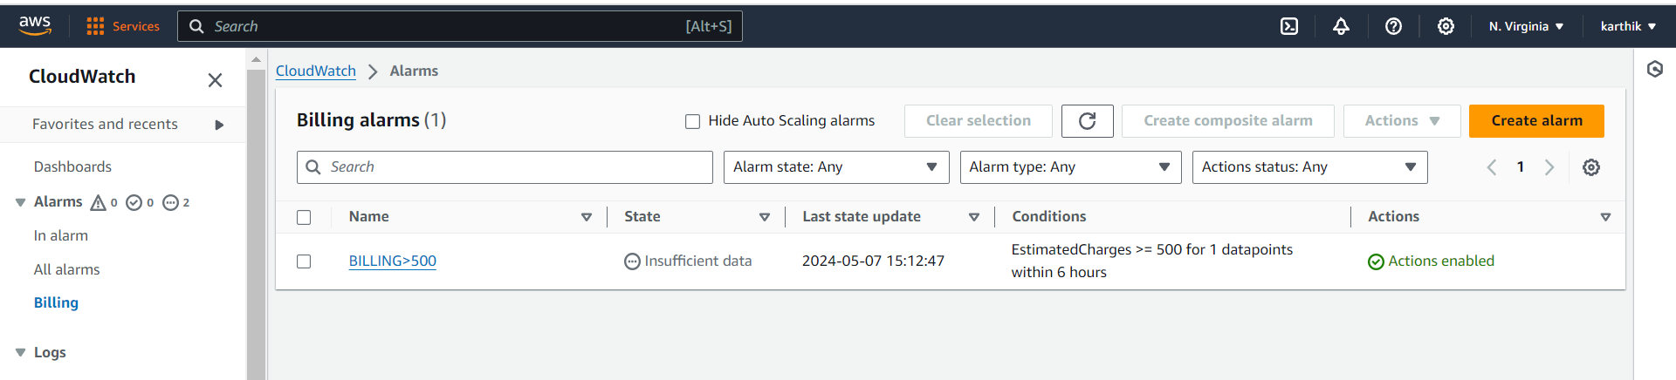

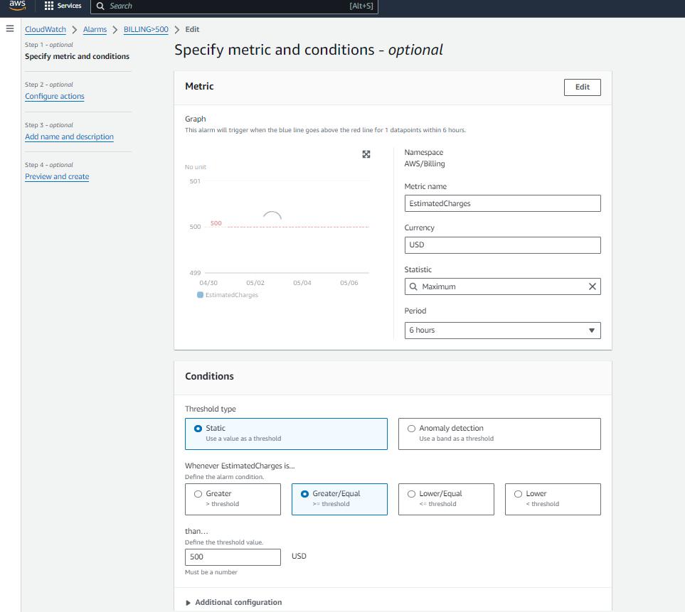

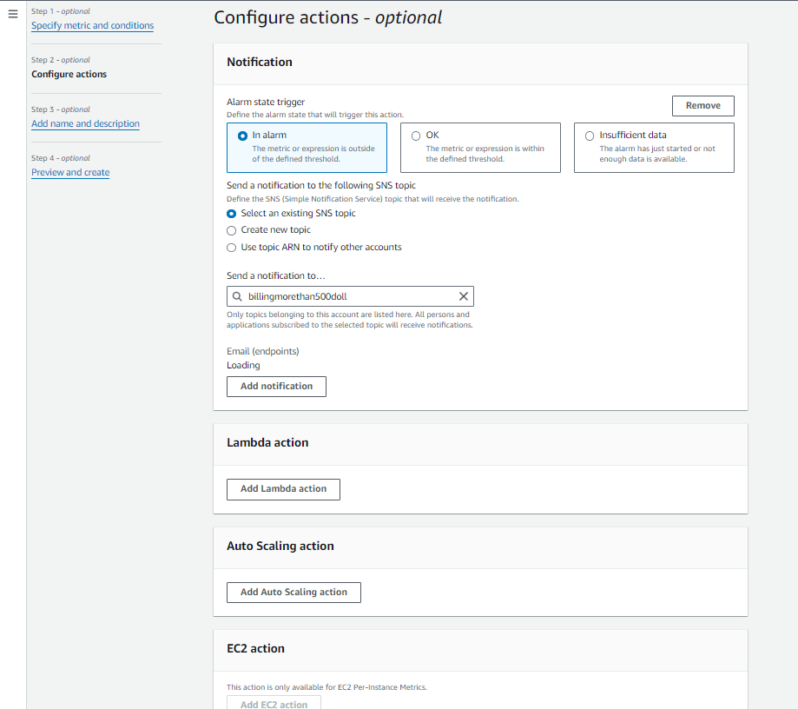

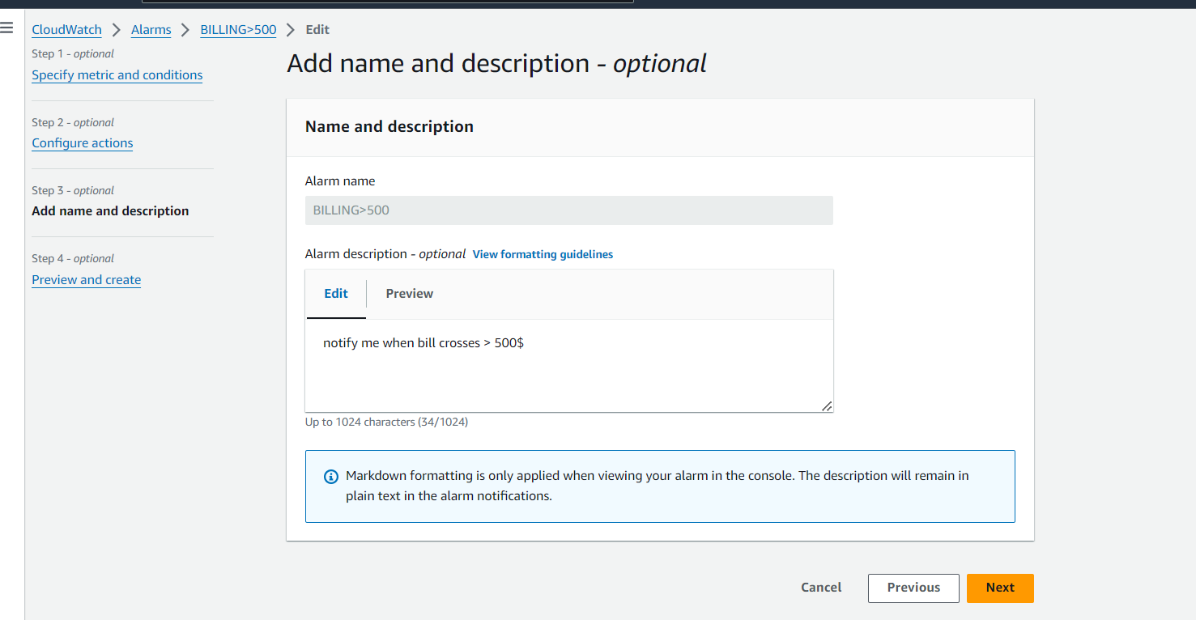



2. Create a CloudWatch alarm which goes off to an Alarm state when the CPU utilization of an EC2 instance goes above 65%. Also add an SNS topic so that it notifies the person when the threshold is crossed.

**Created ec2 instance**

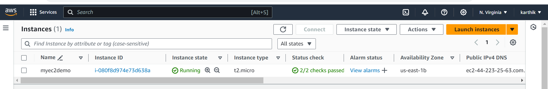

**And created IAM role Trust policy for EC2 with CLOUDWATCH**

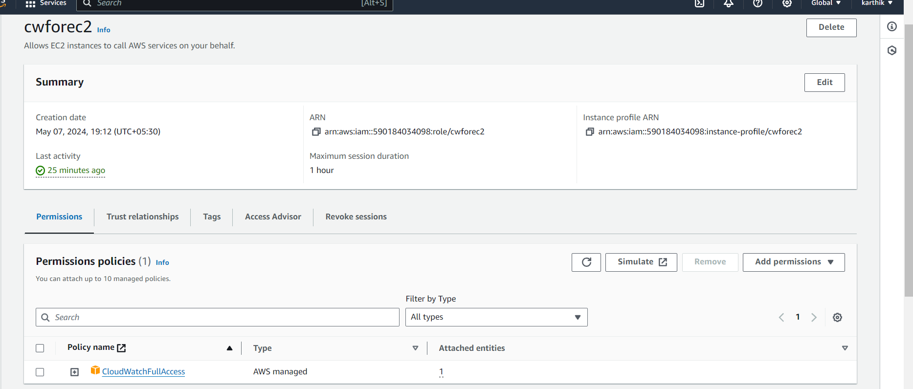

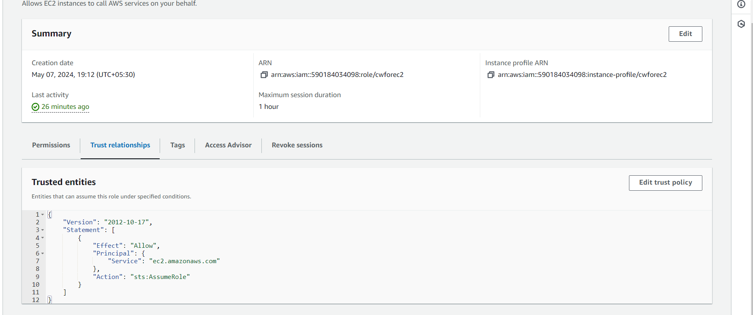

**Created alarm for CloudWatch state when the CPU utilization of an EC2 instance goes above 65%.**

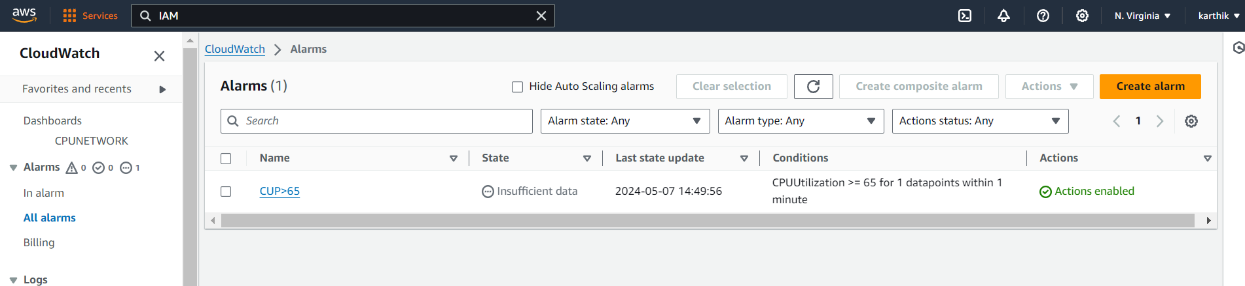

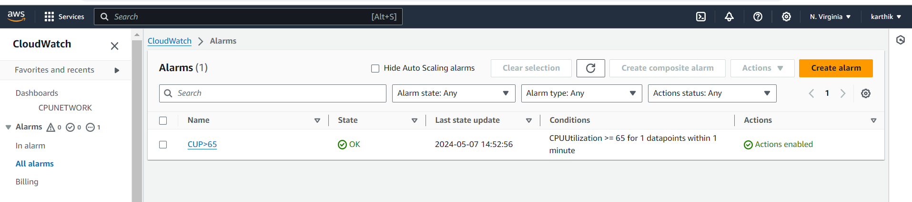

**CPU GRAPH**

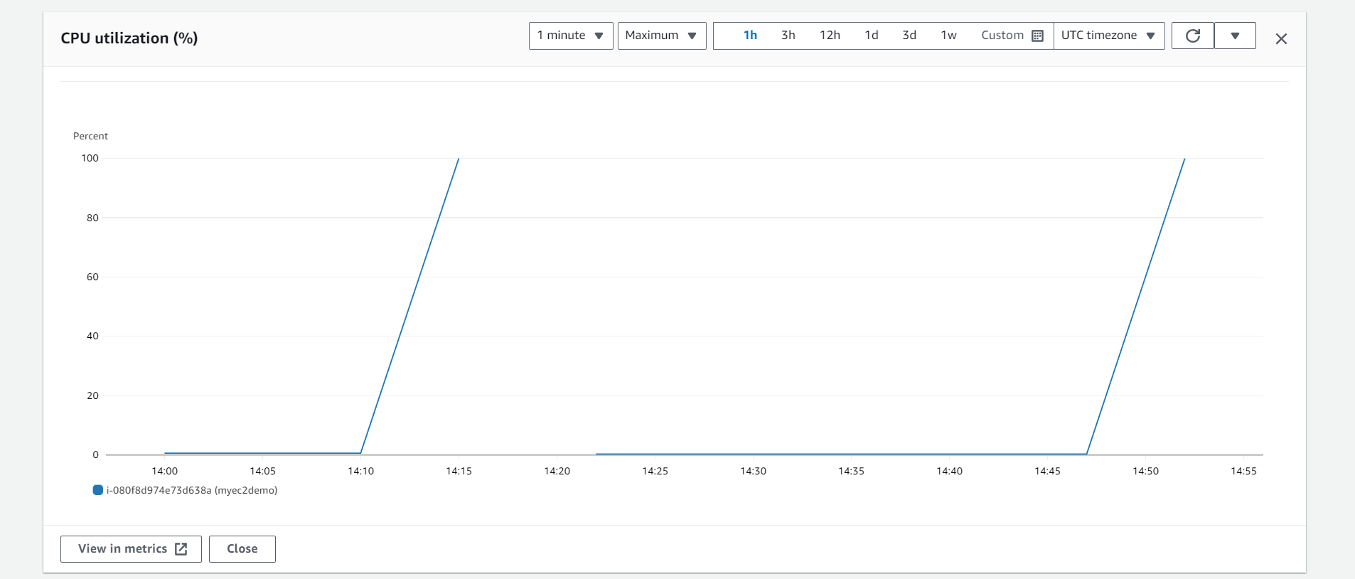

When CPU **utilization cross => 65% alarm in status as in alarm**

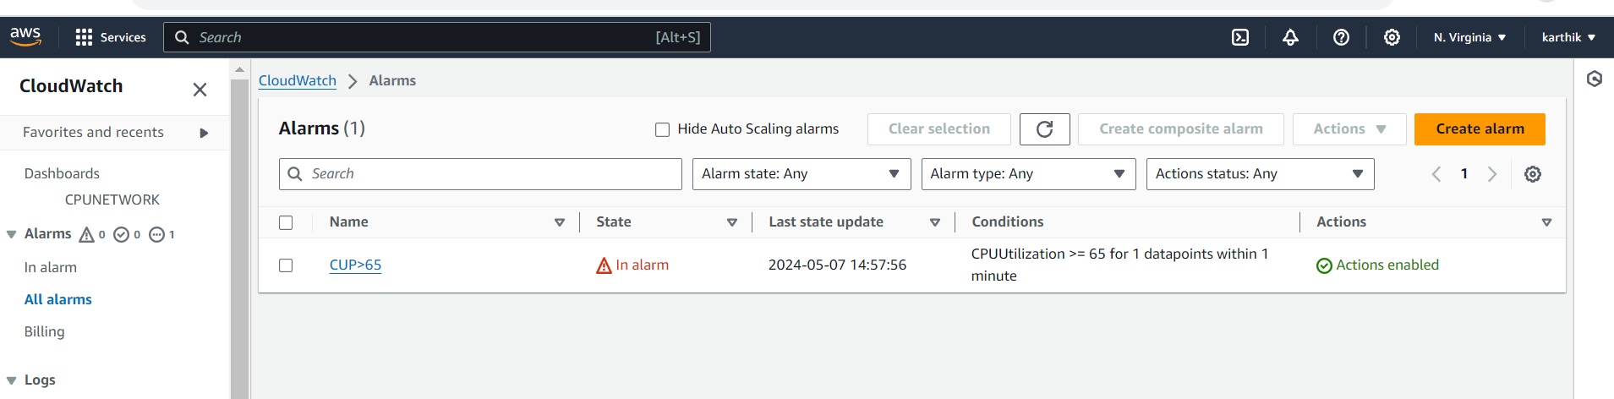

**Received notification when alarm generated**

